**HTML | <th> abbr Attribute**

Last Updated : 01 Aug, 2022

The **HTML <th> abbr Attribute** is used to *specify the shorter version of content in header cell*. It does not describe any visual effect but it is used by screen readers.

**Syntax:**

<th abbr="text">

**Attribute Values:**

* **text:** It contains the short description of header cell content.

**Example:**

**html**

|  |
| --- |
| <!DOCTYPE html>  <html>    <head>      <title>HTML th abbr Attribute</title>  </head>    <body>      <h1>GeeksforGeeks</h1>        <h2>HTML th abbr Attribute</h2>        <table border="1">          <tr>              <th abbr="name of student">NAME</th>              <th abbr="age of student">AGE</th>              <th abbr="branch name">BRANCH</th>          </tr>            <tr>              <td>BITTU</td>              <td>22</td>              <td>CSE</td>          </tr>            <tr>              <td>RAKESH</td>              <td>25</td>              <td>EC</td>          </tr>      </table>  </body>    </html> |

**Output:**

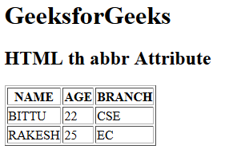

**Supported Browsers:** The browser supported by **HTML <th> abbr attribute** are listed below:

* Google Chrome 1 and above
* Edge 12 and above
* Internet Explorer
* Firefox 1 and above